Training Program
Spring 2023
STAY CONNECTED!

May I grow so tall and bright, so free and wild, so brave and vibrant, that when you
see me standing you think I am a sunflower.
- Gaby Comprés
Mailing Address 700 Logan College Dr. Carterville, IL 62918

Phone
Local: 618-985-5975
Toll free:
1-800-548-5563
618-985-5980
E-mail
ccrr@jalc.edu
Website
www.ccrrjalc.com

CCR&R is dedicated to enhancing children’s lives, with the emphasis on improving the accessibility, affordability and quality of child care, by working together with all families, providers and
communities.
Location
607 S. Greenbriar Road Carterville, IL 62918
Office Hours Mon, Wed, Thurs, Fri
8:00am – 4:30pm
Tuesday
10:30am – 4:30pm
(Hours change during the summer)

CCR&R Training Policies and Procedures

Pre-Registration
You must pre-register for all trainings. Registrations must be received within seven days of the training date. Last minute
registration is permitted if space is available, but materials are not guaranteed. For many trainings there is a minimum number of persons that need to be registered for a workshop to be held or the workshop may be cancelled.

How to Register
⇒You may now register for some training by visiting
www.ilgateways.com then logging in to your dashboard.
⇒Online at www.ccrrjalc.com scroll to the bottom of the page and click on ‘Register for Training’
⇒By phone to Ashleigh Couty at 618-985-5976 X1223
⇒By emailing Ashleigh Couty at ashleighcouty@jalc.edu
⇒By emailing the Specialist assigned to your program

When registering, each person must register individually.
No formal confirmations will be sent before training, however, individuals will be contacted within 48 hours of receipt of
registration if the training is FULL and space is no longer
available. Registration is on a first come/first serve basis.
As a courtesy, CCR&R sends reminder calls before each
training to help participants remember they are registered.
It is essential that your phone number is correct in our
system.

When CCR&R Needs to Cancel a Training
We make every effort not to cancel trainings; however, some trainings
may be cancelled due to:
*Low registration, trainer illness, or inclement weather
*CCR&R follows JALC policy for inclement weather; if the campus closes, CCR&R is closed.

Updating Your Information
CCR&R enters all training information into a central database which ensures training is credited properly and recorded on your Professional Development Record.
- If you have never attended training with CCR&R before or are not a Registry member, you must become a Registry member before we can register you for
training.
- It is important to provide us with a current phone number and email address (if you have one) so we can contact you in case of any changes or cancellations. If there have been recent changes, please complete an
Information Update form.
- Gateways Registry must be updated yearly.

Payments
Payments must be received before the training date. Registration is only complete when your payment has been received. Registration fees are only refundable if cancellation is made five
days prior to a training or if CCR&R cancels.

Late Arrivals / Early Departures
As per our contract with IDHS, to receive a certificate, a participant must be in attendance the entire length of the training. A fifteen (15) minute grace period will be given at all training sessions. This grace period begins at the advertised start time. Participants will not be allowed in the training after the 15-minute grace period. To receive a training certificate, participants must stay until the trainer
is finished.

When a training is cancelled, CCR&R attempts to notify each individual who is pre-registered for training. We will try to give as much notice as possible and reschedule the training at a later date.

When You Need to Cancel Your Registration
Some training has waiting lists. Please let us know if you are not able to attend training so that someone else can take advantage of this opportunity. Registration fees are only refundable if cancellation is made five days prior to a training or if CCR&R cancels.

Financial Assistance for Individuals

CCR&R Individual Professional Development Scholarships
Individual Professional Development Funds (IPDF) are available through CCR&R to assist individual pursuit of professional development in the field of Early Care and Education and School-age Care. Individuals
employed at currently operating legal center and/or home based programs listed on the Child Care Resource & Referral (CCR&R) database are eligible to receive these funds. Funds might be used to help with costs associated with approved workshops, conferences or credentials.
The deadline for PDF applications is June 1, 2024 or until funds are allocated.
IPDF funds are designed to be distributed on a first-come, first-serve basis. As applications are received, priority will be given to providers and centers with 50% or more of their enrollment consisting of IDHS funded children and caring for infants and toddlers.

IPDF Applications are available on the CCR&R website at www.ccrrjalc.com or by request at 1-800-548-5563.
Some upcoming events that are eligible for PDF assistance; Some may still be virtual learning.

ILAEYC local or state affiliate sponsored events SIECAT sponsored trainings
ILAEYC Growing Futures Conference
IL Action for Children’s Spring Into Action Conference IL Afterschool Network Conference
McCormick Center for Early Childhood Leadership’s, Leadership Connections Conference

This list is not inclusive. Please check with Nina at
1-800-548-5563 or ninawargel@jalc.edu if there is a particular
workshop or conference that you are interested in attending to see if CCR&R can lend financial assistance.

Financial Assistance for Programs

CCR&R Accreditation Assistance Funds (AAF) are provided through Quality Improvement Funds to support child care centers and family child care programs in achieving accreditation. These funds may be used to help pay fees associated with the accreditation process.
Funds may be awarded to currently operating child care centers/programs and home based child care
programs listed on the Child Care Resource & Referral (CCR&R) database. AAF are designed to be a first- come, first-serve process, with priority given to providers with 50% or more of their enrollment consisting of IDHS funded children and caring for infants and toddlers
The deadline for AAF applications is June 1, 2024, or until funds are allocated.
QI Fund Applications, and more information on approved activities or expenditures, are available on the CCR&R website at www.ccrrjalc.com or can be requested by calling CCR&R at 1-800-548-5563. Application, activity, approval of applications for approved activities, and payment of funds must occur within the same fiscal year.

Joining the Gateways to Opportunity ® Registry, one of the largest career registries in the state of Illinois, means you are taking an important step in your professional development. Below are tips to help you access the many benefits that the Registry offers. For more information about getting on track with a Registry membership visit www.ilgateways.com.
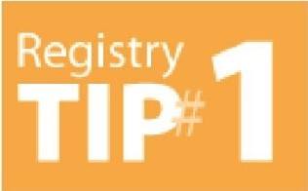Login

I :·
T
P
2
To log into your Registry Membership visit registry.ilgateways.com and click on the Dashboard Login. If you have forgotten your username or password use the red links on the login page to have that information emailed to you.

Print your PDR and Membership Card
try
Re
gi
s
Log lnTo log into your Registry Membership visit registry.ilgateways .com and click on the Dashboard Login. If you have forgotten your username or password use the red links on the login page to have that information emailed to you.Print your PDR and Membership CardOnce you have logged in as a member, click My Registry to enter your Registry Portal and choose the Plan section. Next click the Reports section and then select Get My PDR to print your Professional Development Record. Make sure to choose a start and end date using the correct date format. Or to print your Membership ID Card, choose Reports in the gold bar above the words Professional Development Record. Finally, choose Get Card to access and print your Registry Membership ID Card.
For easy step-by-step instructions, follow along with the Gateways Hot Topic video to print your
Professional Development Record and Membership ID Card.
Hint: Take a photo of your Membership Card and keep this on your phone so you will always have your Registry Member ID when signing into trainings. Also if you are printing your PDR for a DCFS licensing visit, choose the start and end date of your licensing renewal. DCFS accepts training from Section 3, 4 and 5 of your PDR as documentation of pre-service and in-service training. No additional certificates are needed.

I P:·
T
3
Access Free Online Training
try
Re
gi
s
Membership in the Gateways Registry allows access to many free online trainings offered through i-learning. Don't miss the chance to take DCFS and CCAP required trainings, or trainings for ExceleRate Illinois and more by using your same Registry login and password to log into i-learning. Find more information about online trainings at https://courses.inccrra.org/.
Take Advantage of Free Registry Programs
Request a Professional Development Advisor (PDA). Our PDA services can help you set career goals and explore your options in the field, as well as get on track to earn a college degree, complete a Gateways Credential, and more. Click the link below to request a Professional Development Advisor today! www.research.net/r/requestforPDAsurvey
Get a Basic Transcript Review (BTR), which sorts your college coursework into four different categories. The BTR is completed on all official transcripts received by the Gateways Registry. Official transcripts are those sealed in an envelope and sent from an accredited college or university.
Upon completion of the review, your formal education will be reflected on your Professional Development Record (PDR) in sections 1 and 2.
,nc crra:
····••
IUlil10Di$Dtp•lnlenHto!HumanikSrYi<:e5

L0;J 'q-·t\fE\N-1\Y'S TC> Cl\7\7Cl 1 LJ.N! T y ®
0 U Illinois Professional Development System

  - ,4,dministered th rough
..•e!••

Gateways to Opportunities

Gateways to Opportunity is a statewide professional development support system designed to provide guidance, encouragement, and recognition to individuals and programs serving children, youth, and families.
Learn more at www.ilgateways.com

First time & Renewal Applications are
Gateways to Opportunity Credentials
Gateways Credentials are symbols of professional achievement that validate knowledge and skills, experience, and contributions in early care and
education, infants and toddlers, and/or administration.
Gateways credentials are awarded and recognized by the Illinois Department of Human Services (IDHS) Bureau of Child Care and Development. Gateways offers a variety of credentials to professionals in the field of early care and education, school-age, youth development, family child care, technical assistance, and family specialist.
Credentials can be obtained in a variety of ways. Contact CCR&R at 1-800-548-5563 to learn more.
FREE
for a limited time!

Scholarship Program

For more information, or to check out the eligibility requirements,

If you work in a licensed child care center or licensed family/group home, the
Gateways to Opportunity Scholarship program may help pay for you to go to
college.
The Gateways Scholarship
Program is now accepting
applications!
This program can pay for up to 100% of college tuition for courses and degrees in ECE/Child Development.

visit the Gateways website at http://www.ilgateways.com/financial-opportunities/scholarship.

CHANGES
ARE HERE!

STARTING JULY 1, 2022
those making $24 an hour or less AND S49,920 a year or less* may qualify for Great START funding.

If your wages fall within the income limits APPLY TODAY!

For more information, visit www.ilgateways.com and click on Great START or email gstart@inccrra.org.

*All Great START requirements must be met to qualify.

c=:J A;TE\N-f,;,YS TC C C T1.tN!Ty®
0 0
Illinois Professional Development System
Adninlstered through -•.' .
IlllnplDllOeNrin.nHtlJIH1m1mSSIIIVks 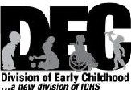

1226Towanda Plaza I Bloomington,Il linois 61701 I Telephone: (866) 697-8278 I www.ilgat eways.corn
in c c r r a : ···•-·•

Gateways to Opport unity is ad ministered throu gh INCCRR1\ and funded by the Illinois Departmem of Human ServicesBureau of Child Care and Development and the McCormick Foundation.
Cate1,vays :o Opp:::,rtunity. the arch logo and Illinois Professional Development Syst em are regis tered trademarks of INCCl18A
P[H oO© )())) INCrn A

Great START Wage Supplement Scale
Job Category Key
A= Assistant
FCC= Family Child Care Provider G = Family Group Provider
T = Teacher D=Director
Great START is available to Assistants, Teachers, Family Child Care Providers, Family Group Child Care Providers, and Directors who work in programs licensed by the Illinois Department of Children and Family Services.

Level | I Option | I Education | I Eligibilityl | I Supp.2
1 | A | 6 semester (9 qtr) hrs in Early Childhood Education (ECE)/Child Development (CD) | A/FCC | 5150
2 | A | Child Development Associate (CDA) | A/FCC | 5225
2 | B | Certified Childcare Professional (CCP) | A/FCC | 5225
2 | C | Montessori Credential (AMS or AMI credentials only)* | A/FCC | 5225
2 | D | 12 sem hrs (18 qtr) hrs toward a degree (9 sem hrs in ECE/CD) | A/FCC | 5225
2 | E | FCC Level 2, SAYD Level 2 | A/FCC | 5225
3 | A | 24 sem (36 qtr) hrs toward an Associates Degree in ECE/CD | A/FCC/G | 5375
3 | B | 24 sem (36 qtr) hrs related field (9 sem hrs ECE/CD) | A/FCC/G | 5375
3 | C | CDA/CCP/Montessori Credential+ 12 sem (18 qtr) hrs toward a degree | A/FCC/GIT | 5375
3 | D | ECE Level 2, FCC Level 3, SAYD Level 3 | A/FCC/G | 5375
4 | A | Approved Community College Early Childhood Certificate | A/FCC/G | 5525
4 | B | 36 sem (54 qtr) hrs toward Associates Degree in ECE/CD | A/FCC/G | 5525
4 | C | 36 sem (54 qtr) hrs toward a degree in related field (12 sem hrs in ECE/CD) | A/FCC/G | 5525
4 | D | ECE Level 3, ITC Level 2, SAYD Level 4 | A/FCC/G | 5525
5 | A | 48 sem (72 qtr) hrs toward Associates Degree in ECE/CD | A/FCC/G | 5675
5 | B | 48 sem (72 qtr) hrs toward a degree in related field (15 sem hrs in ECE/CD) | A/FCC/G | 5675
5 | C | Associates Degree with non ECE/CD major (15 sem (22 qrt) hrs in ECE/CD) | A/FCC/GIT | 5675
5 | D | 60 sem (90 qtr) hrs toward a degree in unrelated field (15 sem hrs in ECE/CD) | A/FCC/GIT | 5675
5 | E | ITC Level 3, FCC Level 4 | A/FCC/GIT | 5675
6 | A | Associates Degree in ECE/CD | A/FCC/G/T/D | 5825
6 | B | Associates Degree in any field with 18 sem (27 qtr) hrs in ECE/CD (21 sem hrs for Dir) | A/FCC/G/T/D | 5825
6 | C | 60 sem (90 qtr) hrs toward a degree in unrelated field (15 sem hrs in ECE/CD) | A/FCC/G/T/D | 5825
6 | D | 90 sem (134 qtr) hrs toward a degree in an unrelated field (15 sem hrs in ECE/CD; 21 sem hrs for Dir) | A/FCC/G/T/D | 5825
7 | A | 72 sem (107 qtr) hrs toward Bachelors Degree in ECE/CD | A/FCC/G/T/D | 5975
7 | B | 90 sem (134 qtr) hrs toward Bachelors Degree in related field | A/FCC/G/T/D | 5975
7 | C | (18 sem hrs in ECE/CD; 21 sem hrs for Dir)  Bachelors Degree in unrelated field (18 sem (27 qtr) hrs in ECE/CD; 21 sem hrs for Dir) | A/FCC/G/T/D | 5975
7 | D | ECE Level 4 | A/FCC/G/T/D | 5975
8 | A | 90 sem (134 qtr) hrs toward a Bachelors Degree in ECE/CD | A/FCC/G/T/D | 57 200
8 | B | Bachelors Degree in related field (24 sem hrs (36 qtr) in ECE/CD) | A/FCC/G/T/D | 51200
8 | C | Bachelors Degree in unrelated field (30 sem hrs (45qtr) in ECE/CD) | A/FCC/G/T/D | 11200
8 | D | ITC Level 4, SAYD Level 5, IDC Level I | A/FCC/G/T/D | 11200
9 | A | Bachelors Degree in ECE/CD | A/FCC/G/T/D | 57, 575
9 | B | Masters Degree in unrelated field (30 sem (45 qtr) hrs in ECE/CD) | A/FCC/G/T/D | 57, 575
9 | C | FCC Level 5 | A/FCC/G/T/D | 51,575
10 | A | Masters Degree in ECE/CD, ECE Level 5, IDC Level II, ITC Level 5 | A/FCC/G/T/D | $1,950
10 | B | IDC Ill, ECE Level 6, ITC Level 6 | A/FCC/G/T/D | $1,950

- A person is only eligible at a level if their job category is shown in the"Eligibility" column. A person will only be eligible at a level if they meet the educational requ irements listed at that level.
- Wage supplements are paid and shown in 6-month increments. Wage Supplements will be pro-ratedif you work 15-29 hours per week. Pract it ioner must remain employed at same child care program to receive 6-month renewal supplement.
*Monte ssori credentials from American Montessori Society or Association Montessori International. All ECE/CD courses must be passed with a "C" or higher.
Credentials other than those listed may be evaluated to determine eligibility as it appli es to your current position .
Foreign transcripts must be evaluated by an evaluation service. The Great START office can assist you in locating one of these services.

LAJ f\r-t::w ys r-C) C)\'\' ,1,tN!,y®
0 0 Illinois Professional Development System
Administered through ■!
·•
..
••••
inccrr a: ··-.
Di!':!'.:",t !:Zffl:!lllood
Wl-10 o;;i 2020 INCCHRA

Ongoing Learning Opportunities
CCR&R facilitates meetings for Center Directors, Assistant Directors, Owners and Head Start Administrators.
Topics and meeting site will vary each month.

Benefits of Participating-
  - Support, Networking & Sharing with others who do the same work as you!
  - Be ‘In the know’ with support from your local CCR&R Quality Team!
  - Visit area programs and get NEW IDEAS to bring back to your program!
Learn with others who know what it’s like in your world!

Meeting schedule will be coming soon.
Network - Share - Support

The Quality Team can provide ongoing learning opportunities for you and your staff suited to your needs. In addition they provide coaching to help ensure what is learned, sticks!
Reach out to a Specialist today to schedule an in-person visit so you can work together to find the right approach that meets your needs.

Quality Specialist - Nina Wargel
Infant Toddler Child Care Specialist - Chrissy Confer
Professional Development Coordinator - Ashleigh Couty
 | Looking for other types of | ongoing support, visit our website
to find a variety of entities that support early childhood
educators through professional development everyday. Go to www.ccrrjalc.com, click on Providers, scroll down to Online learning and more!

Family Child Care Association of Southern Illinois
The Association is open to ANYONE who is interested and able to attend.
Th er e is NO cost to be par t of the Ass ociation.
You can attend one meeting or attend every month!

Benefits of being part of the Association are -

- Support, Networking & Sharing with others who do the same work as you!
- Be 'In the know' with support from your local CCR&R Quality Team
- FREE Annual subscription to Exchange Magazine!
- Babysitting service for all meetings (where ava ila bl e, must be arranged when you RSVP)!
- Technology support for people to attend virtually when they can't att end in person (contact CCR&R for more infor m at io n)!
- Developmental Screening for all child r en birth - five in Family Ch ild Car e Homes who attend Asso ciat ion meet ings.
- with others who know what being a Family Child Care Home Own er is like.

CCR&R sends out an invitation each month via email and US mail.
Meetings take place on the 3rd Tuesday of every month from
6:30pm - 8:30pm

The SIECAT MISSION
To promote, support and enhance the quality of early care and education for children and families in Southern Illinois.

Our members currently serve over 4,000 children
from ISBE PreK/CCR&R's/ Child Care/Consultants.

WHY JOIN?
  - Keep abreast of current issues an d trends.
  - Share ideas & solut ions wit h seasoned educators.
  - Be in vo lved wit h statewide advocacy efforts.
  - Receive free Gateway Regi st ry training opport unit ies.
  - Improve the quality of your early ch il dhood services.
  - Net w or!k with other ear ly childhood prof ession als.
Our members ar ,e currently active in:

GOEC Advisory Committees
!Illinoi s Actio n for Chilld r en IDHSAdv isor y Coun cil DCFS Ad visory Coun cill NAEYC/IAEYC/S IA EYC
Ad visory Boards
for John A Logan Col ilege Kaskaskia Co illege
Illinois Trainers Network Com mitt ee
Illi noi s Schooll- Age
Ch i ldcar e Network Board
NAEYC Vallid at io n
Project Child Resource & Referr al Agency
Chi ld ren's Home & Aid Resource
& Referral Agency
John A. Logan Resource & Referr al Agency
Facu lt y National Louis University, Jo h n A. Logan, SWIC
Wabash Valley Co illege

MONTHLY MEET 'I N GS
We meet the second Thursday of each month (except December) from 10:00 a.m. - 12:00 p.m. at Rend Lake Marketplace, Mt. Vernon, IL
or via Zoom

MEMBERSHIP REQUIREMENTS
Membership dues are $50.00 annually and is open to Professionals
in Early Childhood Education
Attendance of monthly meetings is encouraged.

GATEWAY REGISTRY APPROVED TRAININGS

For more information, call: Dr. Jill Andrews, President (618) 847-7102

CCR&R Training

CCR&R contracts with the Illinois Department of Human Services to provide training and technical assistance to the early childhood professional community. CCR&R’s training is planned around the
results of ongoing feedback from professionals throughout the year, as well as current trends and field focus. Training helps support your work towards continuous quality improvement. You will notice that training is offered in a variety of formats; in-person, virtual, evenings, weekends, series, learning groups, etc. If you are in need of a specific training topic for your staff, please contact CCR&R to explore the possibility of getting a topic added to our calendar or scheduling an on-site training for your group.

Bi-annual Training Survey
In accordance with our contract CCR&R must utilize an ongoing Training Needs Assessment
Survey requesting feedback on desired training and technical assistance topics.

Your feedback and ideas are critical to helping CCR&R meet your professional development
needs. If there is something specific you are looking for, please feel free to contact us at any time and we will do our best to respond to your request. We appreciate the opportunity to serve and support early childhood professionals in southern Illinois and the important work they do each day in caring for and
teaching young children.

Our training needs survey will be available on our website later in the fall. Please watch for an announcement. We would appreciate you and your staff completing the survey.

Beyond the Training

This year CCR&R is taking the ‘Beyond the Training’ program to new heights. We will be launching a learning reinforcement program that helps the training you take, STICK!
We realize that action, behavior change, and retention happens over time and after knowledge has been introduced. That is why we are teaming up with Arist, a company who has brought learning to where people are….on their phones. They are designing impactful learning reinforcement, one text at a time.
The plus for the learner, is that the texts are engaging but short.

According to Harvard magazine “spaced learning spread across 1-2 months can increase knowledge by up to 50 percent, and strengthen retention for up to two years.”
It’s simple, as part of your professional development experience you will automatically be part of our
‘Beyond the Training’ program with Arist.
Please take the time to engage in this text platform, when you are prompted by text, in the days after your training.

Beyond the Training

Please make sure you have a good cell contact number
listed in Gateways. This is the number we will use to text you the training refreshers.

When you attend training
you are making an investment in your future. Often times however, when we return to our programs, life happens and we forget to use what we learn. CCR&R has created Beyond the Training as way of making training ‘stick’.
“Research shows that, on average, students forget 70 percent of what we teach within 24 hours of the training experience.” (Kohn, 2014).
What you learn is critical to what children learn from you, therefore, CCR&R is committed to the concept behind Beyond the Training. This is a FREE service.
For more information: Ashleigh Couty
1-800-548-5563 Ext. 1223
ashleighcouty@jalc.edu
You will receive three ‘boosts’
via text that will require very little on your part, each boost will have a different purpose.
These boosts will help you retain what you learned. At
the same time, your Supervisor will receive information to help support you in transferring
what you learned.

During your last boost, you will have an opportunity to request technical assistance to help
you implement what you
learned during your training.

Because what you do after the training is just as
important as the training itself!

CPR, First Aid and AED Training
Heartsaver Pediatric First Aid CPR AED
In-person:
CCR&R offers CPR and First Aid year round at the three community colleges in our district. We offer classes at least once each month and add classes to meet the need. We pay for all fees if the class is taken at one of these colleges.
Interested in hosting a class for your staff ? You are responsible for payment, but can apply for reimbursement. (see below)
John A Logan: Jo Dick, 618-985-2828, ext. 8534 or via email jo.dick@jalc.edu
Shawnee College: Lora Clark, 618-634-3254 or via email lorac@shawneecc.edu
SIC: Lori Cox, 618-252-5400 or via email lori.cox@sic.edu

Approved CPR and First Aid Providers
Paying for CPR and First Aid

AMERICAN HEART ASSOCIATION
AMERICAN SAFETY & HEALTH INSTITUTE (ASHI) AMERICAN RED CROSS
AMERICAN TRAUMA EVENT MANAGEMENT ( ATEM) EMERGENCY CARE AND SAFETY INSTITUTE (ECSI) EDWARD ATKINSON/EMERGENCY RESPONSE HEALTH NETWORK
ELLIS & ASSOCIATES, INC. EMS SAFETY SERVICES
KNOW CPR MEDIC FIRST AID
NATIONAL SAFETY COUNCIL
R.H. SANDERS/TITAN CPR
PACIFIC MEDICAL TRAINING PRO-TRAININGS, LLC

HELPFUL TIPS
- We suggest that you take a class organized by CCR&R so you know that
you are getting what you need and it is automatically reported to the Gateways Registry
- Be sure that you are taking a Pediatric CPR and First Aid class (if you aren’t sure, give us a call)
If you will be asking for reimbursement and you take a class that is not offered by CCR&R, hold on to your receipt to show that you paid for the class.

When you take a face to face class at a local college campus, it is FREE with no fees. Child Care Resource and Referral will pay for CCAP providers (includes all staff) to
take these classes. When a program schedules training for their staff at their site, the program is
responsible for payment. Funds are available to cover part of this cost by
reimbursement. If you schedule your own CPR/First Aid course from a different approved provider or agency, you can apply for 100%
reimbursement. Contact Nina Wargel at CCR&R to request an application or access the CPR/First Aid Reimbursement form on our website under Child Care Center and Family Home Providers, Grants and
Funding.

CPR, First Aid and AED Training
.
The CPR, First Aid and AED course teaches you how to manage illness and injuries in a child, in the first few minutes, until professional help arrives. This course is for those involved in child care that have a duty to respond to a first aid emergency because of job responsibilities or regulatory requirements. This course is tailored to child care
providers, child care teachers and staff, babysitters, grandparents, foster and adoption parents, pre-kindergarten, elementary and secondary school teachers, camp counselors, youth organizations, and coaches for children's sports organizations.

John A Logan College - Carterville

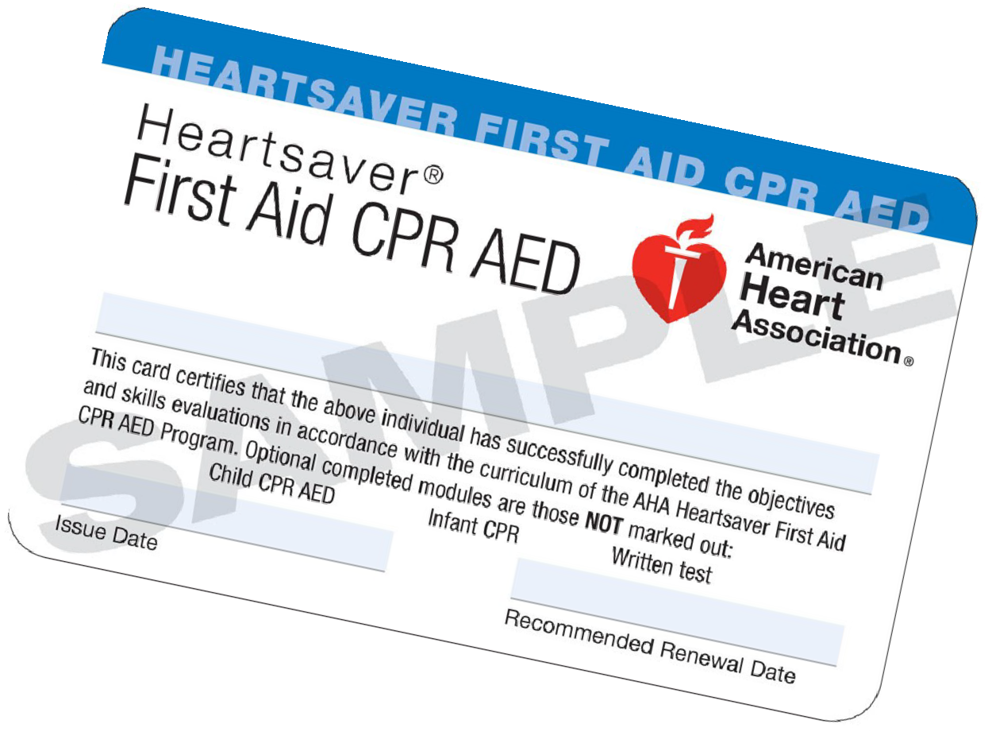Date/Time/Place

Saturday, January 28
9:00-4:30
H 127

Saturday, February 11
9:00-4:30
H 127

Saturday, March 25
9:00-4:30
H 127

Saturday, April 22
9:00-4:30
H 127

Saturday, May 6
9:00-4:30
H 127
Class Information

A short lunch break will be given between CPR and First Aid
sessions.

Please be on time and bring something
to write with.

Additional classes may be added throughout the year depending on need.

CPR, First Aid and AED Training

Shawnee Community College - Ullin

Date/Time/Place

Saturday, March 18
8:30-4:30
J 1024
Class Information

Lunch break is short so please bring your
lunch.

Please be on time and bring something
to write with.

Southeastern Illinois College - Harrisburg

Date/Time/Place

Saturday, February 25
8:00-4:30
G 205
Class Information

Lunch break is short so please bring your
lunch.

Please be on time and bring something to
write with.

If you arrive more than 15 minutes late, you will
not be allowed to enter the classroom.

CPR and First Aid cards will be issued via email using the address given to the Instructor during class. Cards are typically issued within one week of the training.

How to Claim Your AHA eCard

Congratulations on completing your AHA course! One last step will make it official­ claiming your eCa rd. As a reminder, only you can claim your eCard at this time; it cannot be claimed by someone on your behalf.
Please follow these instructions to claim your eCard:

G) You will receive an email from ecards@h eart.org with a link inviting you to claim your eCard online.
If you do not receive this email, please check your Spam or Junk folders prior to alerting your Training Center or
Instructor. To try to prevent the email from being marked as Spam or Junk, please add the email address, eCards.heart.org. to your Address Book or Contacts 1n your email server.

The link within the email will direct you to the Student Profile webpage, which will be prepopulated with your first name, last name, email address, eCard code, AHA Instructor name, and Training Center information. Adding your phone number is optional.
Please check that this information is correct. If it is not, please contact the Training Center directly.

Once you have confirmed that your information is accurate, you will set up a security question and answer to access your eCard(s) in the future.

After setting up your security question and answer, accept the terms and conditions of the site and click "Submit."

You will be directed to fill out a brief survey about the AHA course you just completed. Your answers to these questions will help improve the quality of future AHA trainings.

After you complete the survey, your eCard will be displayed. You will have 3 options to view or print it:
Save as PDF: Upon choosing your preferred size to view, you can save your eCard to your computer for future use.
QR Code : For students with a QR code reader, you can access your eCard on a mobile device as needed.

Printing: Your eCard can be viewed as a PDF and can be printed either wallet size (2.5" x 3.5") to be cut out or full size (8.5" x 11") for easy filing.

Please note that if you do not claim your eCard, you will not be able to show proof of course completion to your employer . If your employer requires proof of completion, you can email them a copy from the eCard landing page.

After you have accessed your eCard, you will receive an email from the AHA confirming that your eCard has been claimed. You should save this confirmation email for your records.

You can view your eCard online through the AHA's website, www .heart.org/cpr/mycards, at any time. Simply enter your first and last name and email address, or the eCard code found on your eCard.

Your employer can verify your eCard at www.heart.org/cpr/mycards to confirm issuance by a valid Training Center and Instructor aligned with that Training Center. Employers are only able to verify your card if you have completed steps 1-5.

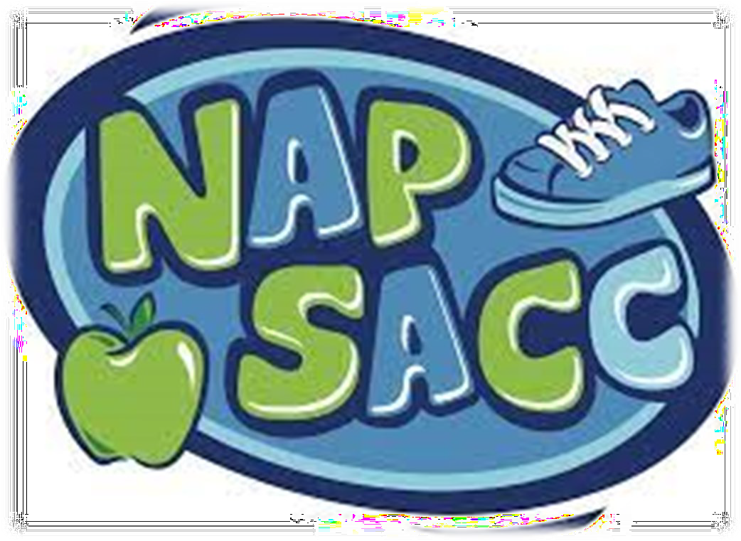Training Opportunities (listed by date)
We will be offering training in-person and via Zoom this Fall.
We know virtual training feels very different than face-to-face training. Our team of trainers will do their best to ensure that everyone has a successful experience. In order for you to be prepared, you must at least ensure that you have the Zoom app downloaded onto any device (cell phone, tablet, laptop, desktop) before the day of the training. If you need assistance, please call our office and someone will be able to help you.
Be sure your email address and phone number are up to date in the Gateways
Registry. The link to your session will be sent via the email on file in the Registry.

An Introduction to ERS

Wed., Feb. 8
5:30-9:30 / CCR&R / $10
Nina Wargel, Quality Specialist
This training is for center-based programs and family child care providers and offers an overview of the Environment Rating
Scales. The Environment Rating Scales are user-friendly assessment tools that measure the quality of the learning environment for infants through school-age children. After completing this training, participants will be able to use the tool(s) for program self-assessment and improvement planning.

Go NAP SACC Cohort

ADMIN Plus 1 or 2 staff
Centers and FCC
*MUST ATTEND ALL SESSIONS
Thurs., Feb. 9 / 6:30-8:30
Thurs., Mar. 9 / 6:30-8:30 Thurs., Apr. 13/ 6:30-8:30
CCR&R / FREE
Toni Kay Wright, U of I Extension Educator
SEE FLYER ON NEXT PAGE FOR MORE
INFORMATION

Training Opportunities (listed by date)

Creating Healthier Environments for Children to Thrive

By using the Go NAP SACC 5-step process - early care and education to make positive changes to support children's health.
Programs can:
enhance their nutrition and physical activity environment,
improve policies and practices, and have a positive impact on childhood obesity.
Join our upcoming cohort!

February 9
March 9
April 13
6:30PM - 8:30PM
Child Care Resource & Referral Office Register at: www.ccrrjalc.com
Sites should consider attending in groups of 2 or 3 staff. Must have a Director/Owner.
Cohorts also can include teachers, cooks, or family support staff.
This cohort will provide engaging lessons, hands-on activities, and group sharing to support nutrition and physical activity in early care and education sites.

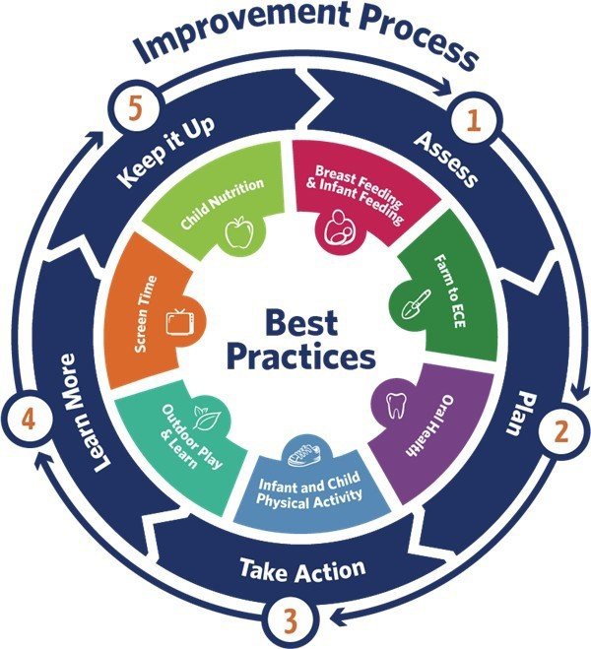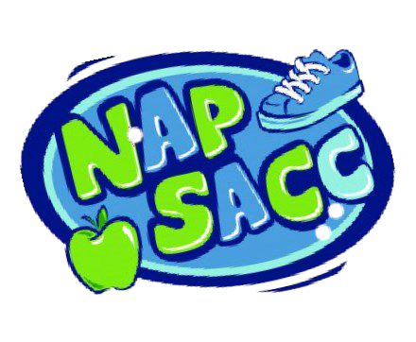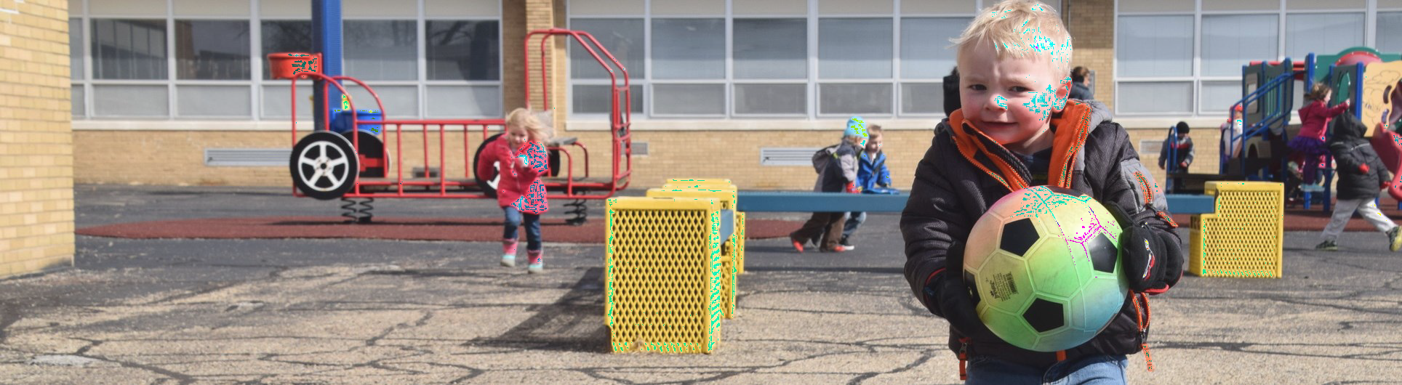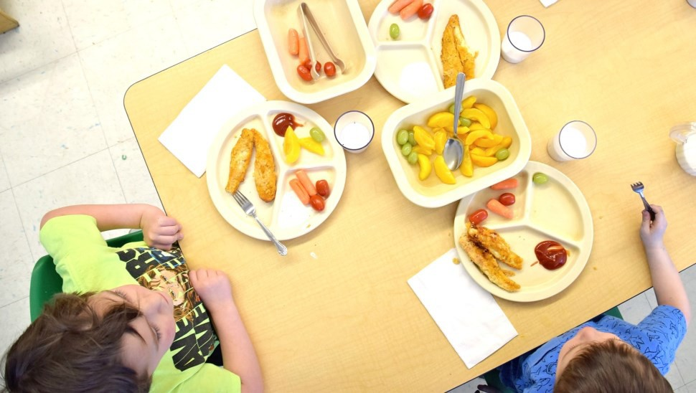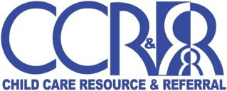
Source: Go NAP SACC, University of North Carolina

“Taking the time to complete the assessments gave me the push I needed to update our center’s menus and increase our variety of fruits and vegetables. We were also very hesitant to offer our meals family style, but by starting small we were able to be successful. Now, I couldn’t imagine serving meals any otherway.”
- Jackson County Child Care Center
Children that are healthy will be more ready to learn.
This institution is an equal opportunity provider. This material was funded by
USDA’s Supplemental Nutrition Assistance Program - SNAP. College of Agricultural, Consumer and Environmental Sciences University of Illinois |
United States Department of Agriculture | Local Extension Councils Cooperating
. Illinois Extension: https://go.Illinois.edu/EatMoveSave.

Training Opportunities (listed by date)

Gardening in Education

Thurs., Feb. 16 / 6:30-8:30 / CCR&R / FREE
Toni Kay Wright, IL Extension
Young children can explore new fruits and vegetables with all five senses – especially when engaged in
gardening activities. Whether early care and education sites have raised bed gardens, container gardens, or just do simple garden-based food activities; children learn about healthy, fresh fruits and vegetables. Children are more likely to taste and eat fruits and vegetables that they take part in growing or preparing. Join us as we
explore options and opportunities for gardening education in early care and education sites.

Survival Kit for Toddlers

Tues., Feb. 21 / 6:30-8:30 / CCR&R / FREE
Chrissy Confer, Infant-Toddler Specialist
Toddlers, they are a breed of their own. They seem to know it all and are not shy about telling you what you are doing wrong. Sometimes it feels like you are just trying to survive the day in the toddler classroom. Being prepared is such an important strategy. In this training, participants will gain tools to put into their toddler survival kit.
Participants will learn how to address potty training,
routines, and challenging behavior.

Addressing Secondary Trauma

Wed., Feb. 22 / 6:30-8:30 / ZOOM / FREE
Rachel Brenningmeyer, Prevent Child Abuse IL
This training session will introduce attendees to the importance of being aware of how secondary trauma impacts both their
professional and personal lives. Attendees will develop a deeper understanding of secondary trauma and other related
conditions. Participants will be introduced to a short assessment that determines what aspects of their own lives are causing
more stress, and will then learn strategies on how to reduce
secondary traumatic stress. This training will provide attendees with various self-care activities that can be utilized at an individual, as well as, at an organizational level.

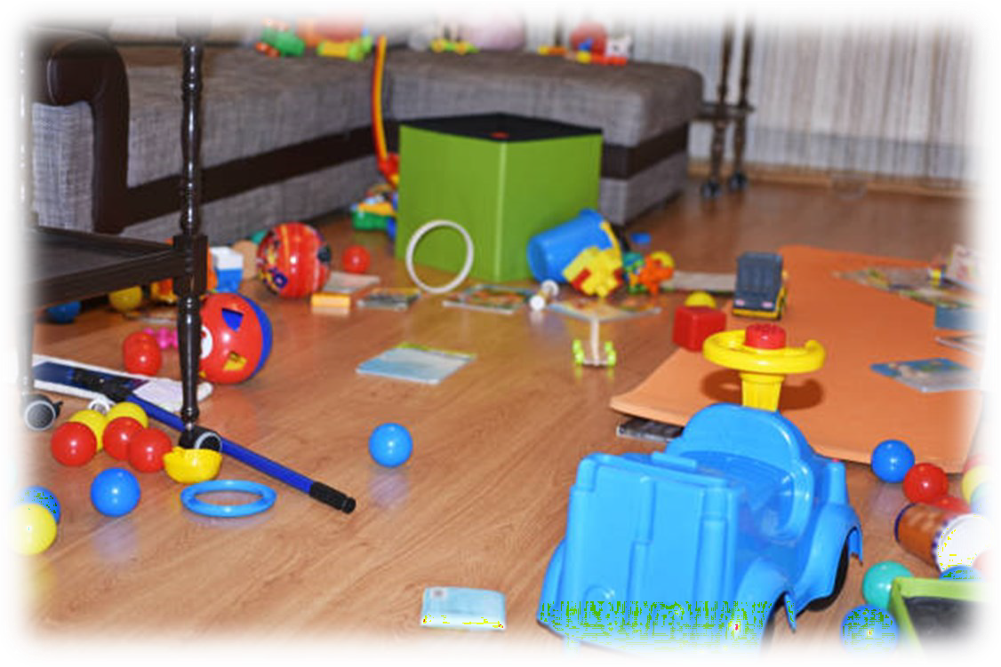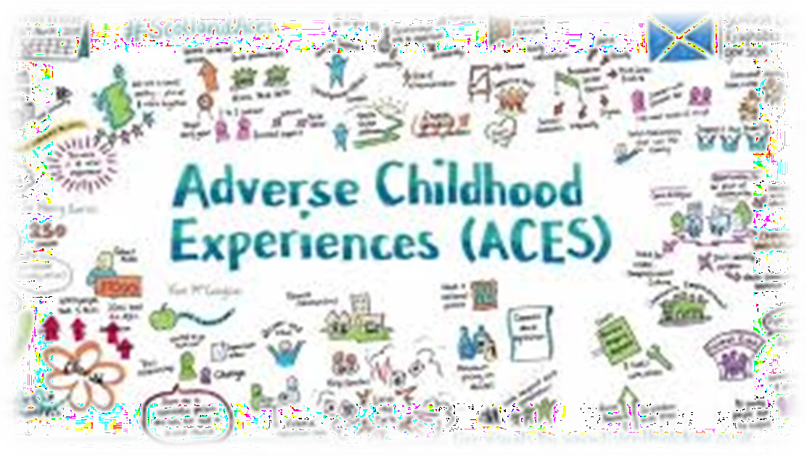Training Opportunities (listed by date)

Simplify Your Life By Decluttering

Tues., Feb. 28 / 6:30-8:30 / CCR&R / FREE
Robin Ridgely, U of I Extension Educator
Does the clutter in your house or at work cause you
stress? Do you have at least one room that is off limits to company? Is the clutter a cause for conflict with other family members or colleagues? Do you want less clutter but you
are too overwhelmed to begin? Many of us struggle to keep up with the clutter in our lives. In this session we will
explore reasons why we hang on to clutter and learn ways to organize your life in order to clear the clutter and reduce your stress.

Art for Babies

Thurs., Mar. 2 / 6:30-8:30 / CCR&R / FREE Colleen McLaughlin, ECE Consultant
Babies love creating and making. Come learn some new ideas to refresh your art curriculum for infants, toddlers and twos. Discussion will include the elements of art and color
theory. Come prepared to paint!!

Understanding ACES:
How the Body Keeps the Score

Tues., Mar. 14 / 6:30-8:30 ZOOM / FREE
Rachel Brenningmeyer, Prevent Child Abuse IL
This training introduces participants to the Adverse Childhood Experiences study that was done in the late 1990’s.
Participants will learn how and why the study was conducted and conclusions due to the study. This training will explore a
deeper understanding of brain development and what types of stress impact healthy brain development. Participants will learn how adverse childhood experiences impact lifelong physical and mental health. The conclusion of this
training will focus on resilience and how building resilience can negate the negative impacts of adverse childhood experiences.

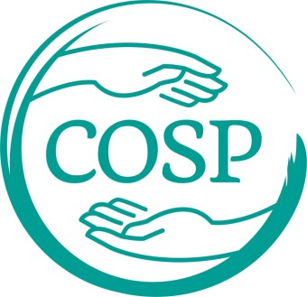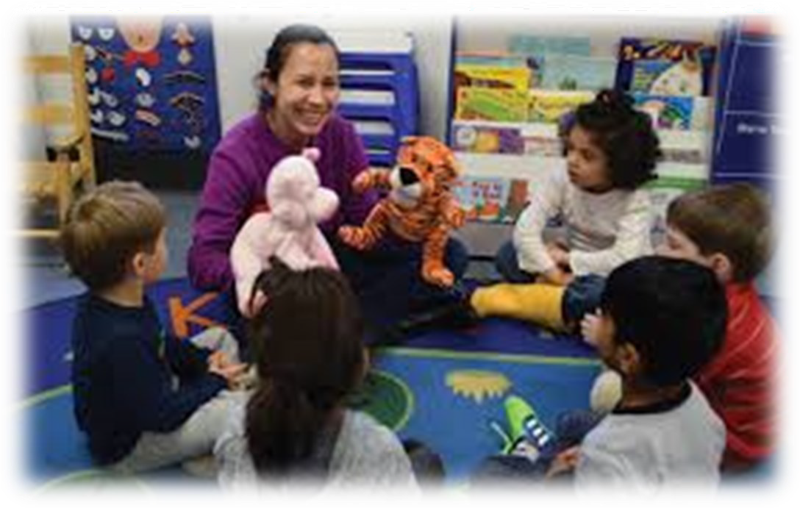Training Opportunities (listed by date)

Incorporating Social Emotional Learning Toys and Materials
(brought to you by RSI, scan QR code to learn more)
Tues., Mar. 21 / 6:30-8:30 / CCR&R / FREE
Colleen McLaughlin, RSI Consultant
This hands-on workshop will introduce participants to the newly established Library for Social Emotional Learning. We will play social emotional learning games and discuss how to use them in your classroom or program.

Circle of Security Parenting™ & Caregiving-Abbreviated: Increasing Positive Attachment in Child Care

*MUST ATTEND ALL SESSIONS Wed., Mar. 22 / 6:30-8:30
Wed., Mar. 29 / 6:30-8:30
Wed., Apr. 5 / 6:30-8:30
Wed., Apr. 12 / 6:30-8:30
Mendy Dale & NaTasha Hubbard / ZOOM / FREE
Circle of Security Parenting™ /Caregiving-Abbreviated is a series training consisting of 4 sessions utilizing an eight- chapter, video and interactive discussion on an attachment-based approach that helps build caregivers' ability to view young children's behavior from a secure base and safe haven perspective and then identify children's needs, challenges, and strengths. This enables caregivers to increase positive attachments with the children in their care
which supports positive developmental outcomes for young children.

Social Emotional Strategies: Making Connections Between Self-regulation and Learning

Thurs., Mar. 23 / 6:30-8:30 / CCR&R / FREE
Nancy Gulley, ECE Consultant
Participants will examine and identify a variety of strategies to help children with self-regulation and learning within a
preschool environment. Participants will create a vision board to help identify specific strategies to create a more positive
learning environment that encourages child self-regulation and social emotional development.

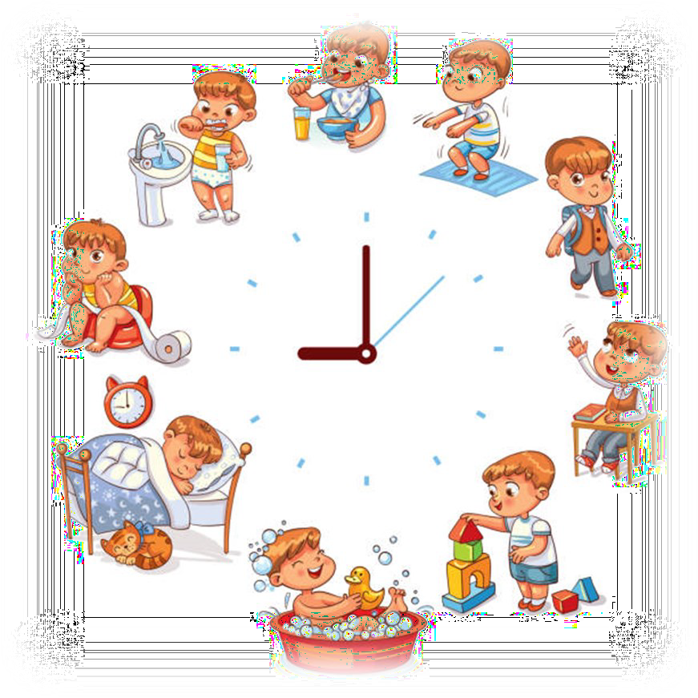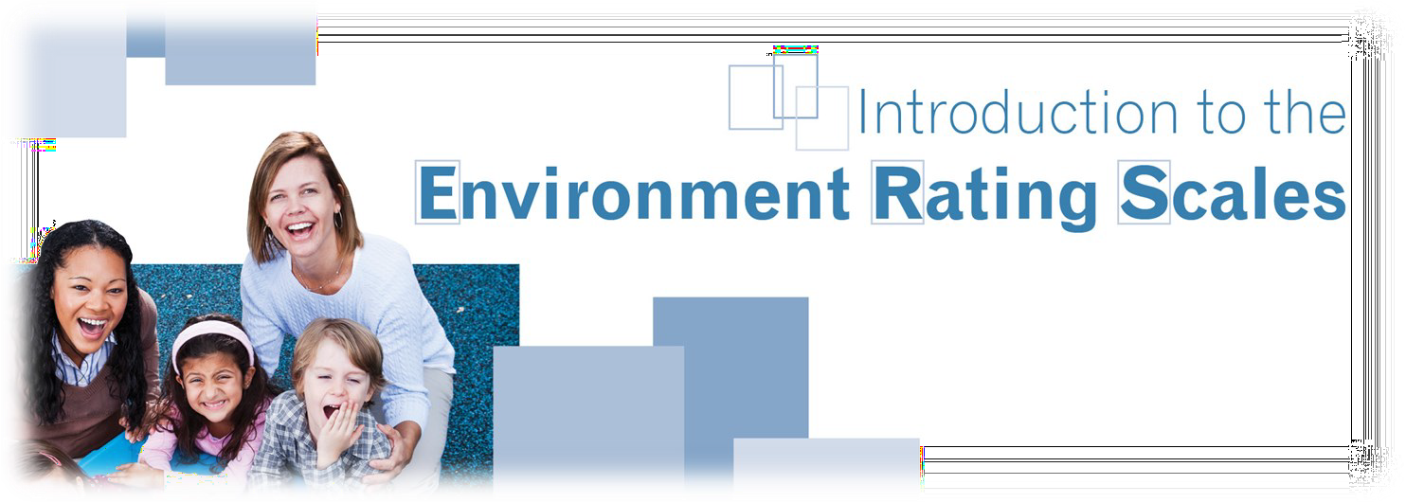Training Opportunities (listed by date)

Let’s Talk About Stress, Baby!

Tues., Mar. 28 / 6:30-8:30 / CCR&R / FREE
Robin Ridgely, U of I Extension Educator
Stress is a funny thing. It can be something helpful that gets us motivated to get our work done. But if we don’t find an outlet for it and allow it to build, we can
experience negative effects mentally and physically. In this program, we are going to talk about stress and also the importance of self-care. We will explore variety of practical techniques that can be used to manage stress and improve health and well-being. We’ll also talk about protecting our time, setting boundaries and the
importance of accountability.

More Than Just a Routine

Tues., Apr. 4 / 6:30-8:30 / CCR&R / FREE
Chrissy Confer, Infant-Toddler Specialist
Change the diaper, feed a bottle, put them to sleep and repeat. Routines can feel like a never-ending loop. You put yourself on autopilot and just get the job done. But routines should be anything but routine. They should be viewed as special opportunities to
interact with each child one-on-one. Well-carried-out routines can have a major impact on young children. In this training participants will discover ways to improve their routines. Participants will learn that routines are a major part of the curriculum, should be
individualized, and help to strengthen relationships.

An Introduction to ERS

Thurs., Apr. 6 / 5:30-9:30
CCR&R / $10
Chrissy Confer
Infant-Toddler Specialist
This training is for center-based programs and family child care providers and offers
an overview of the Environment Rating Scales. The Environment Rating Scales are user-friendly assessment tools that measure the quality of the learning environment for infants through school-age children. After completing this training, participants will be able to use the tool(s) for program self-assessment and improvement planning.

Training Opportunities (listed by date)

Strengthening Business Practices for Centers

*MUST ATTEND ALL SESSIONS

Tues., Apr. 11 / 6:00-9:15
Tues., Apr. 18 / 6:00-9:15
Tues., Apr. 25 / 6:00-9:15
Tues., May 2 / 6:00-9:15 CCR&R / FREE
Ashleigh Couty, Professional Development
Coordinator
The Strengthening Business Practices for Centers training addresses basic concepts in fiscal and operational
management of child care programs. The purpose of this training is to strengthen childcare provider’s foundational knowledge of fiscal terms, concepts, and practices. It encourages providers to realize the
importance of fiscal planning to the sustainability of their business operations. It provides tips and best practices in fiscal, organizational, and financial goals and human resource documents in order to help break down the fiscal processes into manageable steps.

“The more that you read, the more things you will know. The more you learn, the more places you’ll go.”— Dr. Seuss

Math for Babies

Thurs., Apr. 20 / 6:30-8:30 / CCR&R / FREE
Colleen McLaughlin, ECE Consultant I know what you’re thinking, NOT MATH! Many of us have this reaction to our favorite subject. But math can be fun and is for babies! Join us to learn what math concepts are important for children 0-3. You will gain strategies for making math fun and game-like for your little learners.
Don’t worry, there won’t be a test.

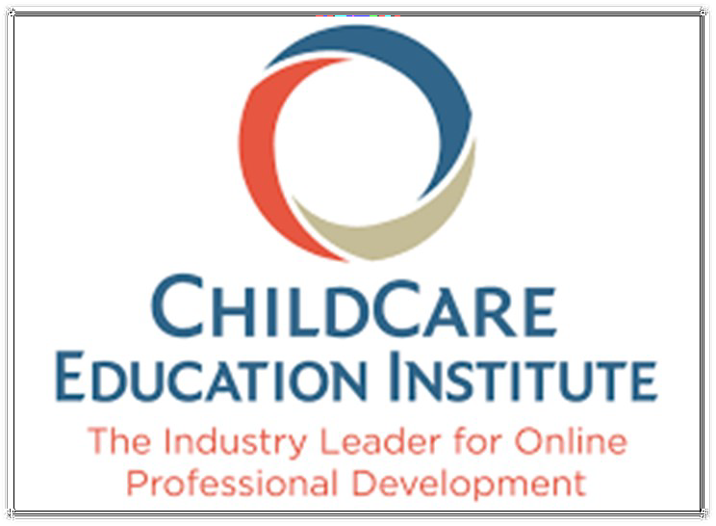E-Academy Online Training Sessions (Pending Available Funds)
Looking for online options?
Visit CCR&R’s E-Academy on our website, where you can access workshop titles not found on the CCR&R calendar. CCR&R offers a variety of online workshops that you can do “on demand”, 24 hours a day, seven days a week. The first 10 hours are provided free of charge to individuals who work at programs listed in the CCR&R database or for individual pursuing a family child care license.

Online workshops are available to you 24 hours per day, seven days a week. You can take them at home and at work.
You will need an internet connection, a good operating computer, and printer. Certificates for online workshops can be printed upon completion of the training.
These trainings must be self-reported in order for them to appear on your professional
development record.
See what some professionals say about CCEI Training
“I love it…. I can do it on my own time, when I am ready.”

“They're available at any time. I can take my time and really understand what I am learning.”

“Many different subject areas are offered and you can do it in the comfort of your own home.“
These courses are
Gateways approved.

Get started NOW!
- The FULL list of CCEI courses is available on their website https://www.cceionline.com/
- Decide which workshops you want to take - write down the course name and
course number
- Contact Ashleigh Couty at ashleighcouty@jalc.edu to register.

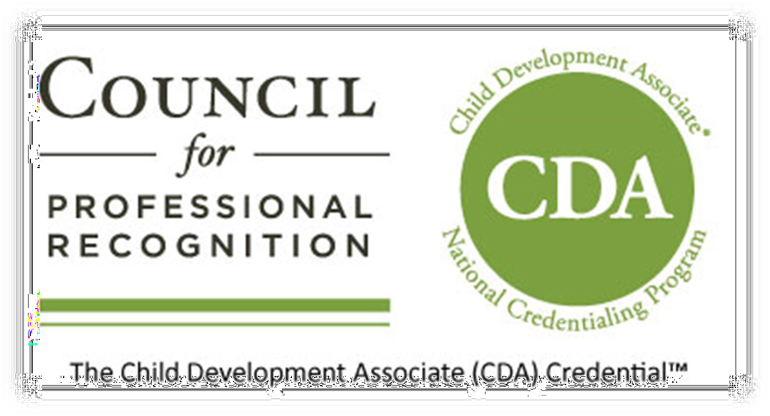Workforce Development Support

We know that finding qualified teachers is a concern . CCR&R implemented CDA Credential cohorts in 2019 to assist staff in attaining Child Development Associate Credential (CDA) which is one pathway for a person to be DCFS teacher qualified.

If you would like more information about the credential or the cohorts, contact
Nina Wargel at CCR&R at 1-800-548-5563 Ext.1229

To learn more about the CDA Credential, go to www.cdacouncil.org.

John A Logan College is now offering apprenticeships for students pursuing an early childhood education degree.
Apprenticeships are Win/Win/Win
#1— Apprentice is PAID to work while in college
#2— Employer getting an employee/apprentice who they may/may not have to pay for out of pocket while in training** Employer may be eligible for an Illinois state tax credit for up to $3500/year/apprentice.
For more information contact Tammy Gwaltney at Tammy.Gwaltney@jalc.edu

Apply now for scholarships for the 2023-24 academic year!
ECACE scholarships are available for undergraduate education at participating Illinois colleges and universities and can cover up to the total cost of attendance after other financial aid received--costs such as tuition and fees, room and board, and books and supplies.
Scholarship eligibility criteria include:
  - Currently working or having worked in positions such as teacher, assistant, or director in early childhood centers, schools, or homes; and membership in the Gateways to Opportunity® registry.
  - Enrollment or acceptance for enrollment on a full- or part-time basis at a public or non-profit private 2- or 4-year ECACE-participating institution in Illinois, as an undergraduate student, pursuing an early childhood education major or postsecondary credential.

Learn more:
For more information about eligibility, a list of participating institutions, and to apply, visit www.isac.org/ECACEscholarship

Questions? Need assistance? Contact: Kathleen Riggs
CCR&R Higher Education Navigator kathleenriggs@jalc.edu
800-548-5563 ext. 1238

Illinois Student Assistance Commission
ISAC
ISAC #3796 06/22 (ON 3796 OM 06/22) Printed by authority of the State of Illinois

How can you ensure that the seminar/conference/workshop you register for will benefit your professional development? Try asking yourself these questions beforehand:
- Do you have any "gaps" in your professional development that need to be filled?
Some possible examples are that you need to fulfill your inclusion training hours, or need more hours toward acertification or advanced degree.
- Does the training count toward a Gateways Credential?
Ifyou are interested, inquire with the event planner and/or look on the Gateways Statewide Online Training Calendar to see if the training shows a gold-colored rectangle. You can check the search box on the online training calendar to see if the training may meet the requirements for a Gateways Credenti al.
htt ps://registry .ilg ateways.com /be-a-member/find-tr ainings
- Does the training count toward CEUs or PDUs?
Check with the event organizer to see if the training has been approved for these credit options.
- Is there a specific new skill you are interested in learning?
For example, do you want to learn how to design a PowerPoint presentation, Enrich your science area, Improve observation skills? etc.
- What level of training are you seeking? Introductory, Intermediate or Advanced?
You may be advanced in your knowledge of child development but need a beginner class on accounting skills or documentation.
- Do you want to participate in ExceleRa te® Illinois approved trainings?
As you pursue an ExceleRate Circle of Quali ty, several resources are available to guide your professional development planning efforts in an effort to meet participation requirements. Refer to the ExceleRate Jllinois Required Training Grids for Licensed Family Child Care QL Licensed Child Care Centers at http://www.excelerateillinoisproviders.com/resources/helpful-links QL search "approved for ExceleRate" on the Statewide Training Calendar http s://registry.ilgateways.com/be-a-member/find- trainings
- Is the content focus for family child care, centers, infant/toddler, 3-5 or school-age/youth development?
Look on the Gateways Statewide Online Training Calendar using one as your keyword. htt ps://registr y.ilgateways.com/be- a-member/find-tr ainings
- What outcomes are you seeking? Is the training applicable to your needs?
- Will your individual learning style be addressed? What various methods for learning are used?
- Is the location and time a good fit for you?

Lf"'J \q--A;r-t=:wAys r-c c \"\"c r-u,Nt r-y ®
0 0 Illinois Pro fessional D evelopment System

- i\dnini;teredthrougt-
ll li ■,oi Dcpartmoatof Human 6an'i«le

•., ••
IDHS

1226 Towanda Plaza I Bloomington, Illinois 61701 I (866) 697-8278 I www.ilgateways.com

Goteways to Oppor tunity Is administ ered through lnccrraand funded by the Illinois Department of Human Services Bureau of Child Care and Development and the McCorm ick Foundat ion.
-..
1n c c r r a : -·-•.
Gate·.-va·vs to Opportunity, the arch logo and Illinois Professional Development System are regist ered trad emarks of lnc::rra

There are a variety of trainings that Administrators and teaching staff are required to complete for ExceleRate Illinois. The following related and required trainings have been bundled together to count towards designated Gateways Credentials. When the outlined combination of trainings are completed, (as noted) they may be applied toward an applicant's Gateways Credential. Most of these trainings are available at http://courses.inccrra.org.
To see if you may have already completed a bundle of these trainings, or to see how close to completing a bundle you are, visit your Professional Development Record through the Gateways Registry at registry.ilgateways.com.

ExceleRate Bundle
  - ExceleRate® Illinois Orientation
  - Understanding and Planning for Continuous Quality Improvement
  - Creating Individual Professional Development Plans
Credential
Personal and Professional Development (PPD) EGE Credential - OR - Personal and Professional Self-Awareness (PPS) Illinois Director Credential
ExceleRate Bundle
  - Illinois Early Learning and Development Standards
  - Illinois Early Learning Guidelines OR Finding a Curriculum that Works for You
  - Introduction to Developmental Screening Tools
  - Fundamentals of Child Assessment
Credential
Observation and Assessment (OA) AND Curriculum or Program Design (CPD) EGE Credential - OR - Observation and Assessment (OA) AND Educational Programming (EP) Illinois Director Credential
ExceleRate Bundle
  - Family and Community: Partners in Learning
  - An Introduction to Transitions
  - Basics of Culturally and Linguistically Appropriate Practices
Credential
Family and Community Relationships (FCR) EGE Credential - OR - Family Partnerships (FP) Illinois Director Credential
ExceleRate Bundle
  - Getting Ready for the PAS
  - Introduction to the ERS
Credential
Curriculum and Program Design (CPD) EGE Credential - OR - Educational Programming (EP) Illinois Director Credential
*Each training may only be counted ONCE toward credential credit across any/all combinations of training bundles.
*Welcoming Each and Every Child, at 7 hours currently counts toward the EGE and IDC.

c:=:;J t\11::W-A_ys 1<:> <:>\7\7<:> 1\,lN!-r-y@
0 0
Illinois Professional Development System
Excele Rat e
ILLINOIS I

Preparing Children for Success

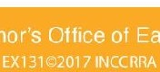1226 Towanda Plaza I Bloomington, Illinois 61701 I p. 866.697.8278 I f. 309.828.1808 I www.ilgateways.com I www.excelerateillinois .com

n
ExceleRate  S vices Bure | 11111101s 1s adrn1n1stered thrOlKJh INCC  au of Child Care a ct Development | RRA 1mdP1 Ille  and the ll1no1 | 101n1 ct1rPclton ot 1he Gov  State Board al Education

I CHILD CARE
What is Infant/Early Childhood Mental Health Consultation?

Infant/Early Childhood Mental Health Consultation (1/ECMHC) is a prevention-based approach that pairs [an infant/early childhood] mental health consultant with adults who work with infants and young children in the different settings where they learn and grow, such as child care, preschool, home visiting, [Early/Head Start,] and early intervention.
Mental health consultation is not about behavior modification. Nor is it therapy. Mental health consultation equips caregivers to facilitate children's healthy social and emotional development.
- Center of Excellence for Infant and Early Childhood Mental Health Consultation at Georgetown University

What 1/ECMHC is? What 1/ECMHC is NOT?
PROMOTION/ THERAPY
.,
PREVENTION FOCUSED Providing clinical Accessing support treatment
before a crisis
Caregiver Connections Intake Coordinator 217.592.0389
caregiverconnections .org bit.ly/lL-IECMHC

Scan the QR code
- Open the camera app
- Focus the camera on the QR code by gently tapping the code
- Follow the instructions on the screen to complete the action

INDIRECT fl

"FIXING THE CHILD"

Primarily working with Creating a behavioral program staff modification plan
e

RELATIONSHIP-BASED COACHING
Working in collaboration Supporting the goals of
with program staff e the learner
ffl
CAPACITY BUILDING SUPERVISION
Helping staff and administrators Monitoring and managing
e
to build self-efficacy staff performance
BIG PICTURE SOCIAL WORK
Exploring common themes Managing family cases across the program and referrals to resources

-- Governor's Office of
<• J
Early Childhood Development
Mental Health
Consultation In Illinois

How can 1/ECMHC support my program?
1/ECMH Consultants provide an opportunity for reflection with administrators, supervisors, and early childhood professionals. This interaction allows all staff to think through their work with a mental health-oriented person, go deeper into a situation, explore options, validate your experience, and come up with the strategies needed to take next steps. 1/ECMHC is NOT an expert giving advice to the members on your team. It is a collaboration, with all involved sharing their thoughts and working together towards solutions.

What are the benefits of 1/ECMHC?

Improved emotional functioning

Reduced challenging behaviors

Reduced suspensions and expulsions
V- Reduced provider stress
-V■ Reduced provider burnout
...for Infants and Young Children

Improved social skills
...for Families, Educators, and Home Visitors
v Improved child-adult relationships
-
Q Reduced p,mnde, tumove,

"Nearly 40% of ECEC programs that have excluded at least one child from their early learning program has never heard of mental health consultation."
-Kate Zinsser, PhD, University of Illinois at Chicago

"Prior to contacting Action for Children, I did not have the resources to refer parents who needed additional support outside of my daycare setting. The consultant shared with me and the parents, organizations which could offer further support, such as family counseling. Having a Mental Health Consultant was also beneficial because after she conducted her own child observation, I was able to share my experience with her, and learn more about how I could support the child when he became aggressive. Having the MHC meet with me and the child's mother and father was extremely helpful because I felt much more confident about what I was
talking about, and because I knew she would be able to answer some of the questions the parents had, which perhaps I might of not been able to answer, had she not been there."
- Early Childhood Professional

Where do I find an Infant/Early Childhood Mental Health Consultant?
As a child care professional you can access FREE Infant/Early Childhood Mental Health Consultation in your community! To request training, technical assistance or Mental Health Consultation please visit the
Caregiver Connections website at caregiverconnections.org or call 217.592.0389 to connect with a consultant in your community.

... Governor's Office of
.'J
Early Childhood Development

Mental Health Consultation In Ill ino is
1/ECMHC : Building Emotional We/I-being,
One Relationship at a Time
bit.ly/lL-IECMHC

Technical Assistance & On-Site Support

CCR&R has a team of trained specialists available to provide technical assistance to early childhood professionals. From environments and curriculum, to staffing and management, our specialists can lend a hand. We are happy to help you meet or maintain any quality improvement goals you may have.

Help is just a call or a click away!
Call 1-800-548-5563

Quality Specialist
Nina Wargel Ext. 1229
ninawargel@jalc.edu

Infant Toddler Child Care Specialist
Chrissy Confer Ext. 1242
chrissyconfer@jalc.edu

“The most efficient and effective route to bold change is the participation of everyone, everyday in incremental change.”
~Tom Peters

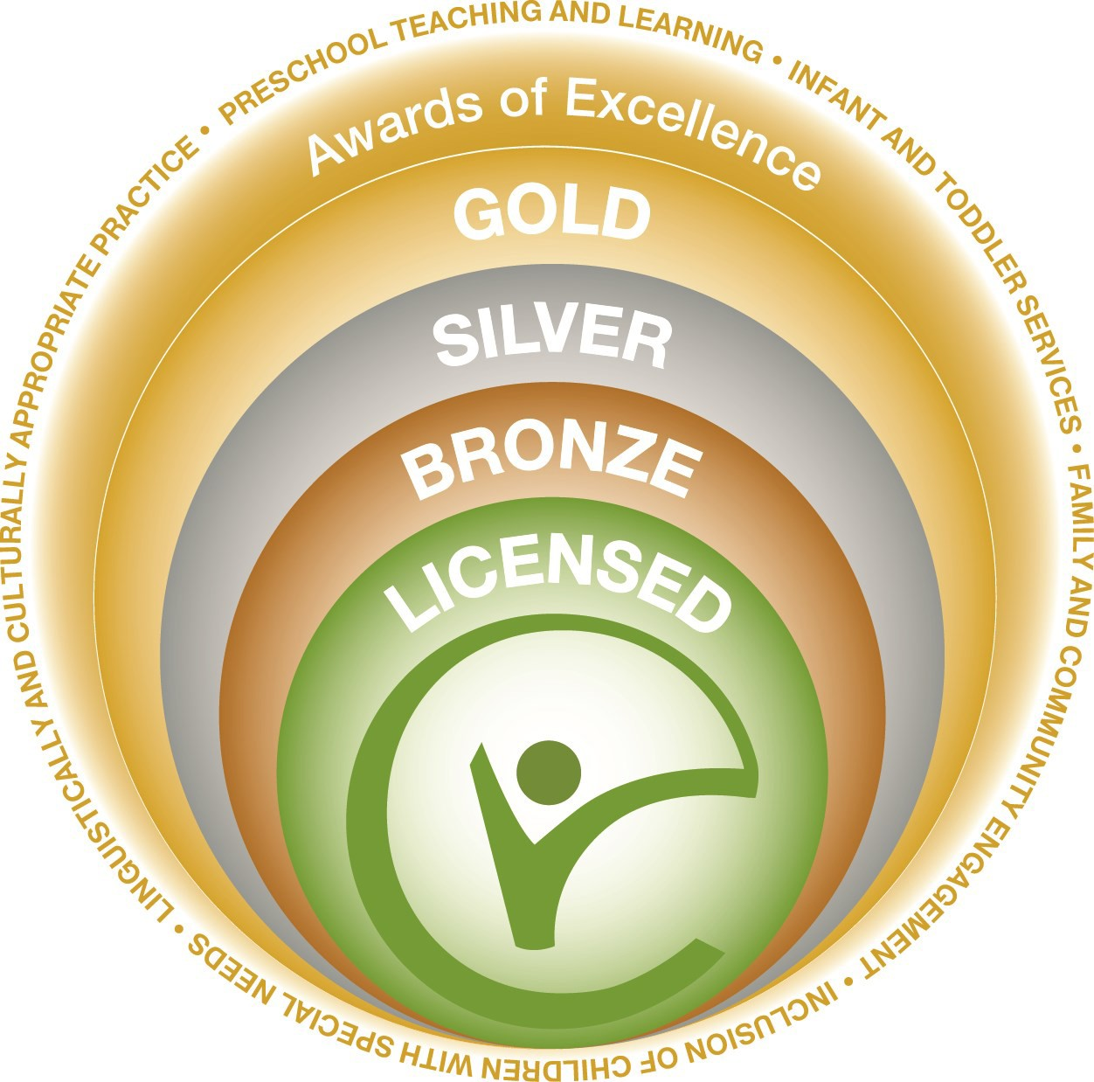
As an early learning and development program, you play a pivotal role in giving our state’s youngest children the best start in life. ExceleRate™ Illinois can help you make quality your top priority and prepare children for
success in school and in life. ExceleRate™ Illinois is a comprehensive system that includes, licensed child care centers, Preschool for All programs, Head Start programs, and licensed family
child care homes. Visit www.excelerateillinoisproviders.com
to learn more.

